**ASSIGNMENT-3**

(TIME SERIES DATA)

SUMMARY:

The Simple LSTM-Based Model with 16 units appears to have the lowest MAE (2.58), indicating the best performance among the models listed here.

The Densely Connected Network Model, 1D Convolutional Model, and models with high MAE values (RNN models) may be ineffective for this task.

Model selection should be based on factors such as computational resources, training time, and the specific problem requirements.

It is important to note that model selection should take account other factors such as interpretability, computational efficiency, and the specific nature of the problem being addressed. Furthermore, additional hyperparameter tuning and cross-validation should be performed to ensure the model's robustness.

USE OF RNN FOR TIME SERIES DATA:

When applied to time series data, recurrent neural networks can provide a variety of benefits and applications. RNNs are particularly effective for analyzing and modelling time series data due to their ability to handle sequential data.

OBSERVATIONS:

|  |  |
| --- | --- |
| MODELS | MAE |
| NAÏVE METHOD | 2.62 |
| DENSELY CONNECTED NETWORK MODEL | 2.71 |
| 1D CONVOLUTION | 3.17 |
| SIMPLE LSTM MODEL | 2.59 |
| MODEL WITH SEQ OF ANY LENGTH | 9.95 |
| STACKING RNN | 9.91 |
| DROPOUT LSTM MODELS | 2.69 |
| STACKED LSTM BASED WITH 32 UNITS | 2.68 |
| STACKED LSTM BASED WITH 8 UNITS | 2.65 |
| STACKED LSTM BASED WITH 64 UNITS | 2.71 |
| STACKED LSTM BASED WITH 16 UNITS | 2.58 |
| LSTM-Dropout, Stacked Model | 2.56 |
| Combined 1D Convolutional with RNN Model | 4.01 |

Based on the data provided, it appears to be a comparison of different models' performance in a test scenario, with the Mean Absolute Error (MAE) as the metric for evaluation. Here is a summary and analysis of the findings:

* This is most likely a simple baseline model that predicts using a basic method. It serves as a starting point for evaluating the more complex models.
* The DENSELY CONNECTED NETWORK model has a slightly higher MAE than the Nave Method, indicating that it may not perform significantly better.
* The MAE of the 1D Convolutional Model is greater than that of the Nave Method and the Densely Connected Network Model. It might not be appropriate for this situation.
* This model outperforms the Nave Method and the Densely Connected Network Model, with a lower MAE. It appears to be a promising option for this task.
* The RNN Model with a high MAE suggests that it is ineffective in this context. It may have difficulty effectively capturing data patterns.
* **STACKED LSTM Model units using 8,16,32,64 units got a best performance model using 16 units.**
* Model Combination of 1D Convolutional and RNN: MAE = 4.01. This model has a higher MAE than most LSTM-based models, indicating that it may not be the best choice for this problem.

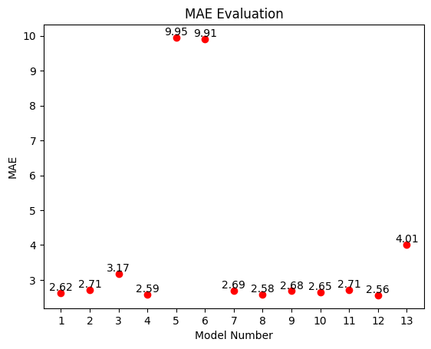

CONCLUSION:

In conclusion, while the Simple LSTM-Based Model with 16 units appears to be the best choice based on the data provided, model selection should take a variety of factors into account, and further validation is required to ensure its effectiveness in real-world applications.

|  |  |
| --- | --- |
|  |  |
|  |  |
|  |  |
|  |  |
|  |  |
|  |  |
|  |  |